Lewis nordan

Homework 2 – Templates

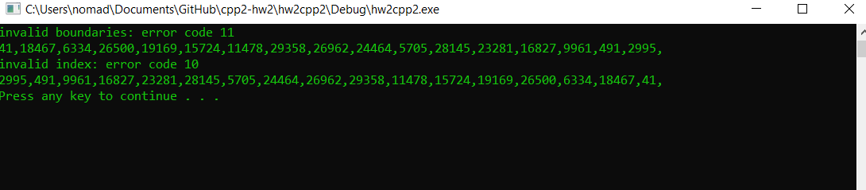

Explain in detail the purpose of C++ Templates and the problem they solve. What are the benefits of using Templates?

C++ templates solve the problem of needing to overload every method in a class for any given data type. The benefit of using a template is that you don’t need to overload every method to account for each data type.